A high-level comparison of the Global Change Assessment Model (GCAM) and the Biomass Scenario Model (BSM)

## Daniel Inman (NREL), Steve Peterson (Lexidyne, LLC), Marshall Wise (PNNL), Jonathan Huster (PNNL)

Acknowledgments

This work is funded by the U.S. Department of Energy’s Office of Energy Efficiency and Renewable Energy’s Bioenergy Technology Office under agreement no. 33691.

List of Acronyms

AEO Annual Energy Outlook

BECCS Bioenergy with Carbon Capture and Sequestration

BSM Biomass Scenario Model

FOA Food and Agriculture Organization of the United Nations

GCAM Global Change Assessment Model

GTAP Global Trade Analysis Project

LDV Light Duty Vehicle

NREL National Renewable Energy Laboratory

ORNL Oak Ridge National Laboratory

PNNL Pacific Northwest National Laboratory

POLYSYS Policy Analysis System Model

Table of Contents

1 Introduction 1

1.1 A Brief Introduction to GCAM 1

1.2 A Brief Introduction to BSM 2

2 Model Comparison 3

2.1 Purpose 3

2.2 Methodology 4

2.3 Major Inputs and Outputs 4

3 Potential Collaborative Analyses 7

4 References 7

List of Figures

Figure 1. GCAM Energy System Regional Resolution 1

Figure 2. GCAM Model Schematic 2

Figure 3. A simplified representation of the modular architecture of the BSM. Different colors are used to denote high-level supply chain stages, each of which contains one or more modules. Arrowed lines indicate information and/or material feedbacks among modules. (Peterson et. al, 2019) 3

Figure 4. Ten USDA-ERS farm regions used in the BSM. Figure from the USDA Economic Research Service………………………………………………………………………………………...4

List of Tables

Table 1. Comparison of GCAM and BSM on the basis of general attributes, energy system represented, agriculture system, and biofuel transportation system representation. 5

1. Introduction
   1. A Brief Introduction to GCAM

GCAM is a long-term, integrated human and earth systems model that economically and physically links regional and global energy, agriculture, land use, and emissions (Wise et al 2014a and 2014b, Clarke et al. 2007, Edmonds and Reilly 1985). GCAM currently models the global energy system with a spatial resolution of 32 regions and agriculture and land use in over 380 regions based on water basins in each region. Energy demands in each region are modeled with different fuels and technologies providing energy services in buildings, transportation, and industrial sectors. Energy production from fossil, nuclear, renewable, and other sources provides inputs for energy transformation sectors like electricity and refined liquids. In each energy transformation and demand sector, multiple future technology options compete based on economics. Figure 1 below shows the regional resolution of the socioeconomic and energy system modeling in GCAM, along with a depiction of the newly-developed GCAM-USA which functions inside the global GCAM model. Figure 2 gives a broad overview schematic of the energy and agriculture links in GCAM.



Figure 1. GCAM Energy System Regional Resolution. Regions are represented by different colors.

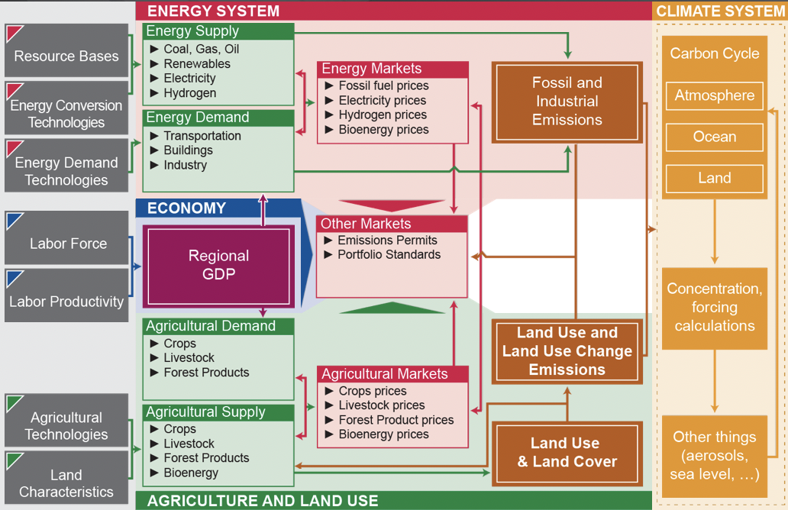

Figure 2. GCAM Model Schematic

GCAM modeling of bioenergy assesses the potential role, impacts, and sustainability of bioenergy production and use that considers complex interactions across all energy and agriculture sectors, both domestic and global. GCAM models bioenergy production from a number of feedstocks including bioenergy crops, residues from agriculture and forestry, and organic municipal solid wastes. Bioenergy crops, which include corn and sugar for ethanol, oil crops for biodiesel, and lignocellulosic energy grasses and woody crops, must compete for land use with food, forest, and other commercial uses of land based on economics. On the demand side, GCAM models bioenergy transformation into energy carriers such as liquid fuels, electric power, gas, and hydrogen, and it can be burned directly in energy end uses for heat and steam. GCAM models the economic competition in each region and sector between bioenergy and fossil energy, nuclear energy, and other renewable resources. Finally, because it models international agriculture, GCAM can account for both the direct and indirect land use implications of expanding land devoted to producing bioenergy crops.

* 1. A Brief Introduction to BSM

The Biomass Scenario Model (BSM) uses a system dynamics approach to provide an analysis platform that can be used to develop and analyze possible evolution paths for the bioenergy supply chain within the United States. System dynamics models can have utility where effects over time are of primary interest (Sterman, 2000), and the BSM uses the STELLA software (isee systems) to represent drivers of supply chain development. The model has undergone multiple major revisions since its initial development. A public version of the model is available on GitHub (<https://github.com/NREL/bsm-public/>), and a list of BSM-related publications and reports is available on online at <https://www.zotero.org/groups/209264/bsm_publications>.

The BSM incorporates a modular, top-down design in which modules are used to capture different stages of the bioenergy supply chain (Figure 3). To facilitate testing and analysis, each module can be configured to run in isolation or in combination with other modules.

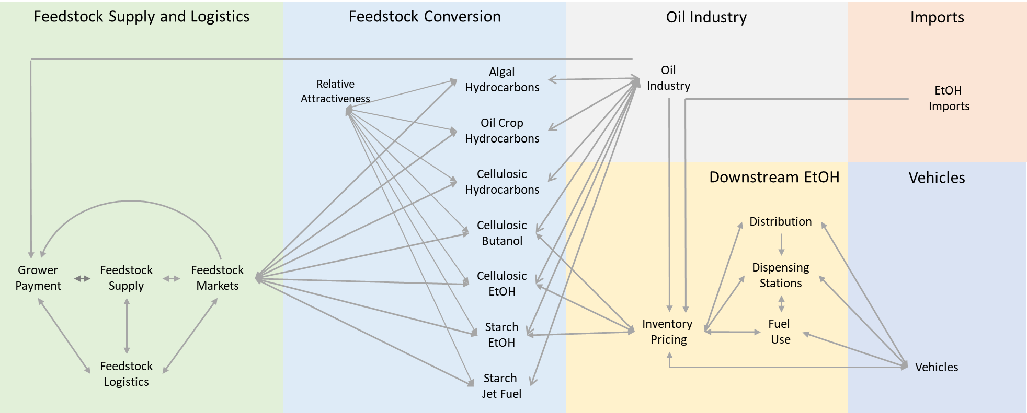

Figure 3. A simplified representation of the modular architecture of the BSM. Different colors are used to denote high-level supply chain stages, each of which contains one or more modules. Arrowed lines indicate information and/or material feedbacks among modules. (Peterson et. al, 2019)

The model divides the continental United States into ten agricultural production regions (Figure 4). Within each region, the model allocates land to commodity crops, to hay and pasture, and to cellulosic feedstock production. Conversion modules focus on dynamics around investment in conversion technologies, conversion of feedstocks into bioenergy products, and industrial learning processes. Downstream ethanol modules address inventory and pricing dynamics for ethanol, while a highly simplified oil industry module transmits oil price scenario information to the system. Finally, within the Vehicles module the BSM tracks light-duty vehicle vintaging, in order to generate a fuel demand signal.

Within the BSM, feedback loops are used to interrelate physical and economic processes. For example, land allocation dynamics (and resultant production of various commodity crops and cellulosic feedstocks) are determined through pricing, which changes over time through imbalances in supply and demand. In the model, feedbacks can cross module boundaries. For example, as indicated in Figure 5, feedstock prices respond to supply and demand signals. Land allocation, and hence, feedstock production, responds to pricing, while consumption of feedstocks responds to price signals as they impact both investment in new conversion facilities and the utilization of existing facilities.

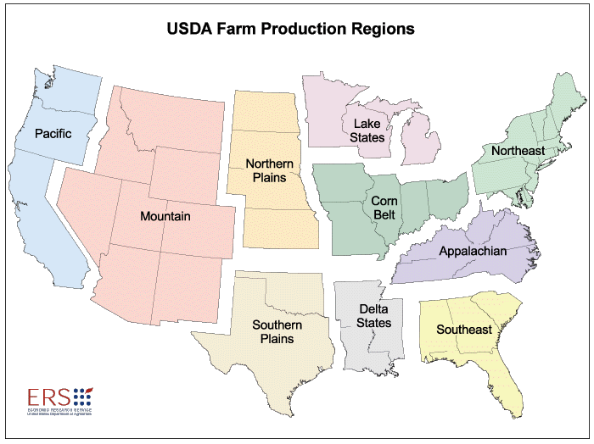

**Figure 4. Ten USDA-ERS farm regions used in the BSM. Figure from the USDA Economic Research Service.** <https://www.ers.usda.gov/webdocs/publications/42298/32489_aib-760_002.pdf?v=0>



**Figure 5. Simplified view of feedbacks relating to feedstock prices in the BSM. (Peterson et al., 2013)**

1. Model Comparison
   1. Purpose

The BSM and GCAM have been used extensively by the DOE and other Federal agencies for gaining insights into the impact and potential trajectory of the domestic bioenergy industries. The two models have been developed with different purposes in mind (as well as project sponsors) and therefore have very boundaries, scopes, and default assumptions. By understanding the relative strengths and weaknesses of the two models, it may be possible to combine the models in ways that lead to more nuanced analyses than either model may provide in isolation.

The objective of this effort is to perform a high-level comparison of the two models based on their scope, boundary, default assumptions, modeling philosophy, technology representation, resource base, and other shared model attributes. This work will serve as a starting point for future collaboration. Defining where the two models overlap will help focus any combined analyses using these two models.

* 1. Methodology

The model comparison was conducted over a two-day meeting held at PNNL’s Joint Global Change Research Institute (<http://www.globalchange.umd.edu/>) from May 7th – May 8th 2019. Because GCAM is global, in scope, and exhaustive in terms of the energy systems represented, the comparison was focused on the components of GCAM that are easily mapped to the BSM modeling space – domestic biofuels production and the US agricultural system.

* 1. Major Inputs and Outputs

A comparison of key inputs and outputs of GCAM and BSM is presented in Table 1. Differences between the models are salient. Because GCAM is global in scope, its representation is broader and includes all global energy and transportation sectors. In contrast, the BSM is a national level model focused on the domestic biofuels market and therefore has more detail complexity around the technological attributes for biofuel pathways and industrial development.

Table 1. Comparison of GCAM and BSM on the basis of general attributes, energy system represented, agriculture system, and biofuel transportation system representation.

|  |  |  |  |  |
| --- | --- | --- | --- | --- |
|  | **Model Characteristic** | **GCAM** | **BSM** | **Notes** |
| General Attributes | Analytical Focus | Global energy, land, and climate | Primarily US biofuels |  |
| Geographic Scope | Global | National (conterminous US) |  |
| Spatial Resolution | 32/384 Globally, 50 States in GCAM-USA | 10 USDA regions | GCAM has energy and economies represented by 32 regions. Agriculture is disaggregated based on water basins to 384 regions. |
| Simulation Length (yr) | 110 (1990 – 2100) | 25 (2015 – 2050) |  |
| Reporting Time Step (yr) | 5 | 1 |  |
| Calculation Time Step (DT) (yr) | Equilibrium at each step | 1/32 |  |
| Modeling Approach | IAM/partial equilibrium | System dynamics (Sterman, 2000) |  |
| Run time | ~30 min | ~ 2 min |  |
| Software | C++ | Stella |  |
| Publicly Available | Yes (GitHub) | Yes (GitHub) |  |
| Architecture | Fixed | Modular |  |
| Energy System | Energy System Represented | All | All transportation fuels; demand for light-duty transportation fuels |  |
| Technology Representation | Specific technologies in energy transformation and demand, generalized elsewhere | Specific DOE conversion processes plus hydroporcessed esters and fatty acids (HEFA) |  |
| Technology Attributes | Explicit Input/output flows of energy, fertilizer, water quantities; capital and other cost assumptions based on technology data | Proforma financials, process performance, technological readiness level, industrial learning |  |
| Market Representation | Global and regional: carbon, water, fossil fuels, renewable fuels, agriculture | Domestic: agriculture, oil, renewable transportation fuels |  |
| Agricultural System | Conventional Agriculture | All food and fiber crops aggregated into 12 categories | Six major crops: corn, soy, cotton, wheat, small grains, hay |  |
| Agricultural Scope | Global markets | Regional markets for hay, cellulosic feedstocks. National markets for commodity crops. USDA projections used for import/export of commodity crops |  |
| Soil carbon | Vegetation and soil C | Not represented |  |
| Initial Agricultural data | FAO, GTAP | USDA, ORNL-POLYSYS |  |
| Biomass crops | Ag and forest residues, dedicated energy grasses and woody crops. | Ag and forest residues dedicated herbaceous and woody crops, urban residues. Initializations from POLYSYS(ORNL) |  |
| Supply and Logistics | NA | Two systems based on Idaho National Laboratory’s Feedstock Supply and Logistics work: Bale-based and Densified |  |
| Land Use | Logit function based on profitability. | Logit function based on relative profitability of land uses | Differences in approach to uptake of new practices and representation of land bases |
| Transportation [bio]Fuels | Technologies | Thermochemical, biochemical | ~15 technologies: starch EtOH, cellulosic EtOH, cellulosic hydrocarbon. Based on specific BETO design cases |  |
| Fuel demand | All modes of transportation | Light-duty vehicles |  |
| Petroleum prices | Endogenous | Exogenous (AEO scenarios) <https://www.eia.gov/outlooks/aeo/> |  |
| Technological learning | Not represented | Endogenous |  |
| Boundary | Impact from tail pipe | LDV fuel consumption |  |

1. Potential Collaborative Analyses

While it is conceptually possible to collaborate by connecting the two models in some fashion, for example, to facilitate exploration of the dynamics that occur between calculation steps of GCAM, a physical connection between the two could require significant development effort. A simple approach to collaborative analysis involves comparison of scenarios generated independently in each model. Consistent results can help to build confidence in the underlying structure and assumptions of each model, while divergent results provide an opportunity for improving system representation. Additionally, comparison of runs can inform design of scenarios and model experiments. The following collaborative analyses can easily be executed:

* Scenarios around high demand for biomass-based electricity generation
* Understanding the implication of industrial learning in the context of targeted GCAM scenarios – e.g. BECCS
* Impact of oil prices on domestic biofuels production under various global carbon target scenarios.

1. References

Clarke, L., J. Lurz, MA Wise, JA Edmonds, SH Kim, SS Smith, HM Pitcher. 2007. Model Documentation for the MiniCAM Climate Change Science Program Stabilization Scenarios: CCSP Product 2.1a. PNNL Technical Report. PNNL-16735.

Edmonds J, Reilly JM. 1985. Global energy: assessing the future. Oxford University Press.

Sterman JD (2000) Business Dynamics: Systems Thinking and Modeling for a Complex World. Irwin McGraw‐Hill, New York

Peterson, S., Bush, B., Inman, D., Newes, E., Schwab, A., Stright, D. and Vimmerstedt, L., 2019. Lessons from a large‐scale systems dynamics modeling project: the example of the biomass scenario model. System Dynamics Review, 35(1), pp.55-69.

Peterson, S., Peck, C., Stright, D., Newes, E., Inman, D., Vimmerstedt, L., Hsu, S. and Bush, B., 2015. *Overview of the biomass scenario model* (No. NREL/CP-6A20-60172). National Renewable Energy Lab.(NREL), Golden, CO (United States).

Wise, M.A., J.J. Dooley, P. Luckow, K. Calvin, and P. Kyle. 2014a. Agriculture, land use, energy and carbon emission impacts of global biofuel mandates to mid-century. *Applied Energy*. doi: 10.1016/j.apenergy.2013.08.042.

Wise, Marshall, Katherine Calvin, Page Kyle, Patrick Luckow, James Edmonds. 2014b. Economic and Physical Modeling of Land Use in GCAM 3.0 and an Application to Agricultural Productivity, Land, and Terrestrial Carbon. *Climate Change Economics*. Volume 5, Issue 2. pp. 1450003-1-1450003-22. DOI 10.1142/S2010007814500031.